WhatsApp Clone Project

IMAGES FOR REFRENCE :-

1. CHAT PAGE

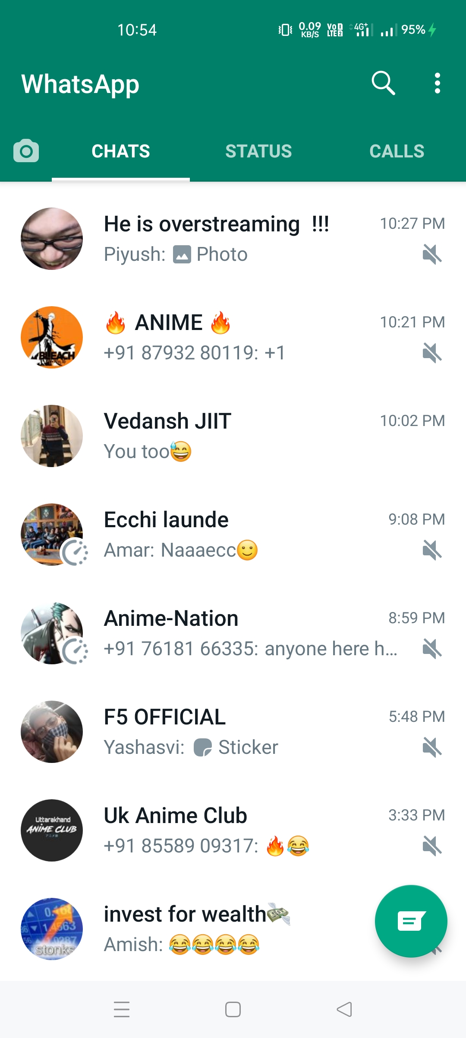

1. STATUS PAGE

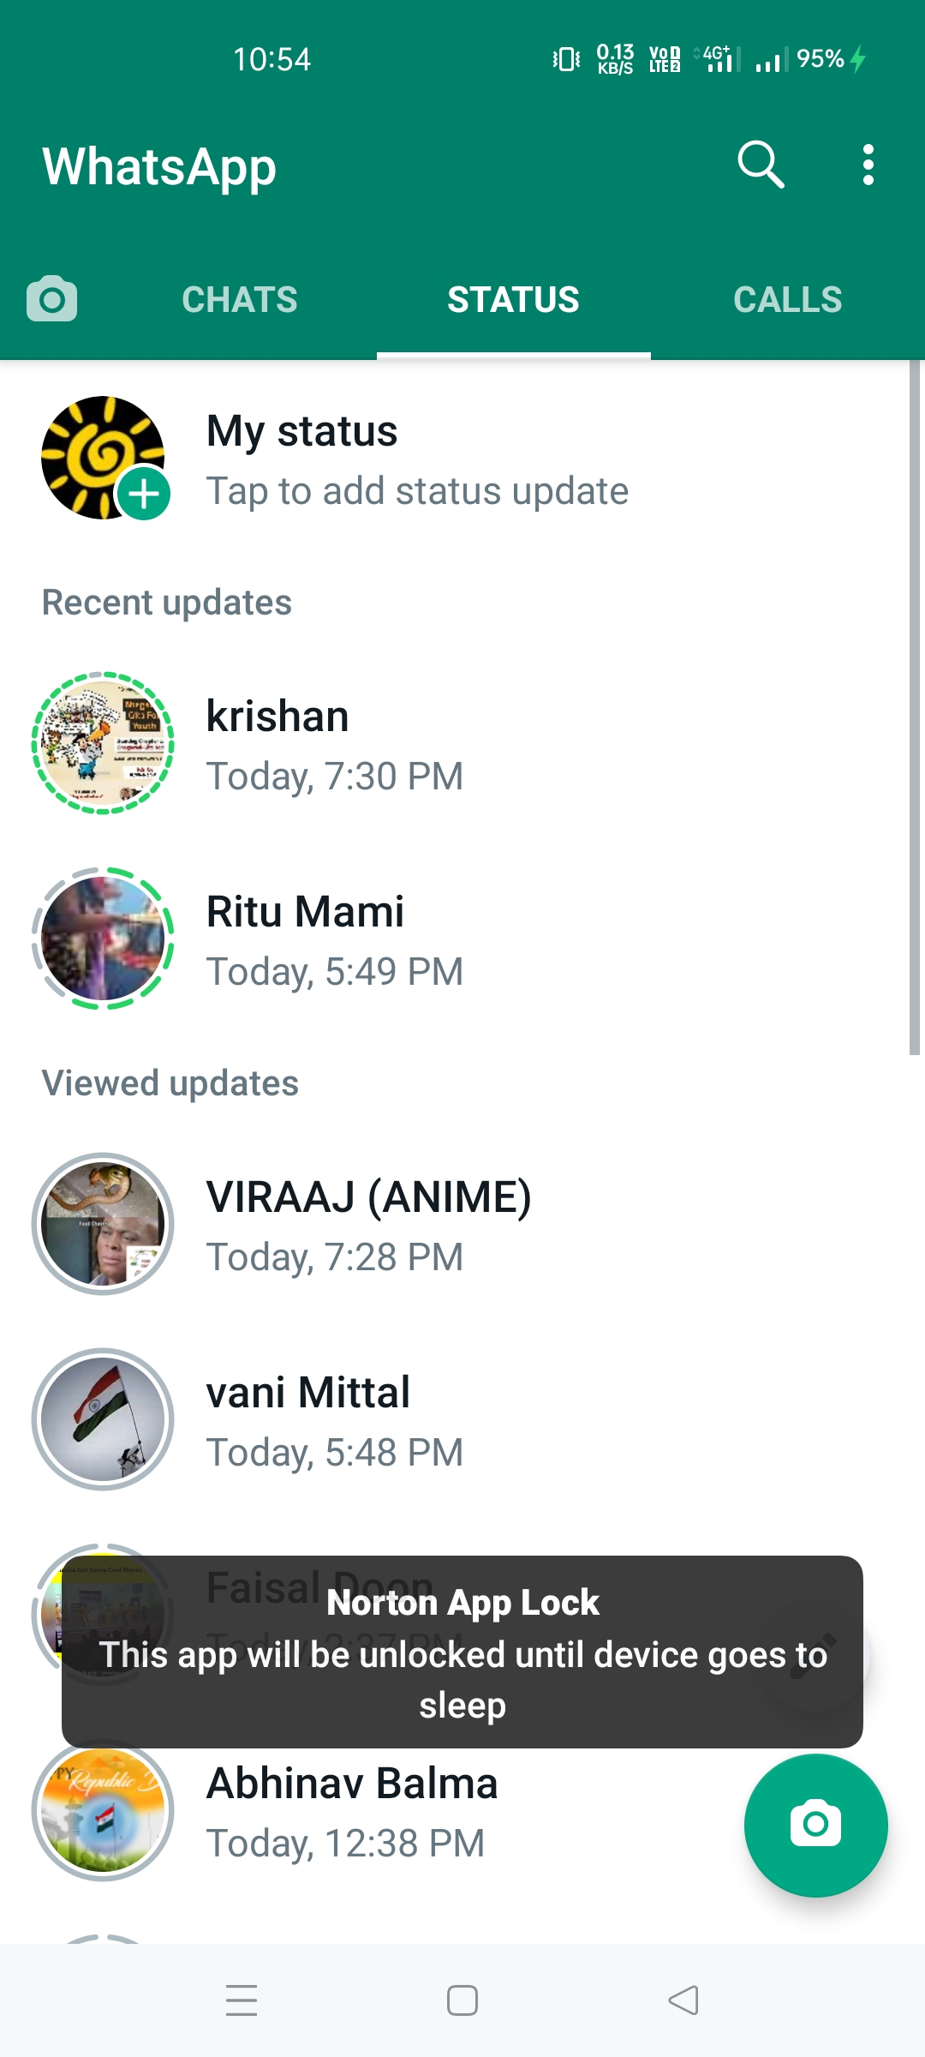

1. CALL PAGE

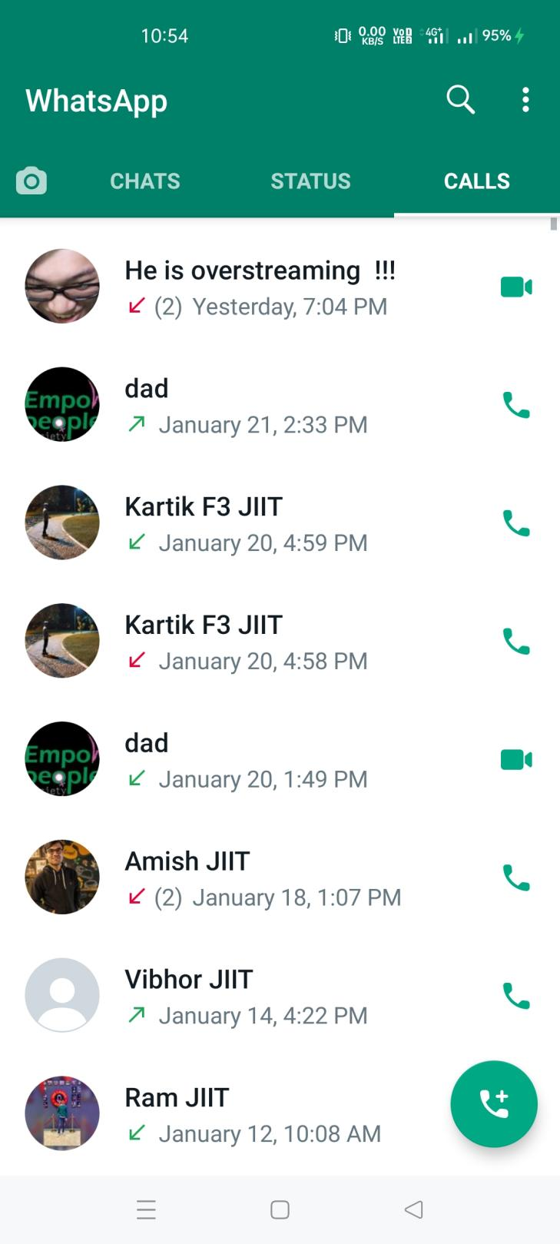

1. CHAT ROOM PAGE

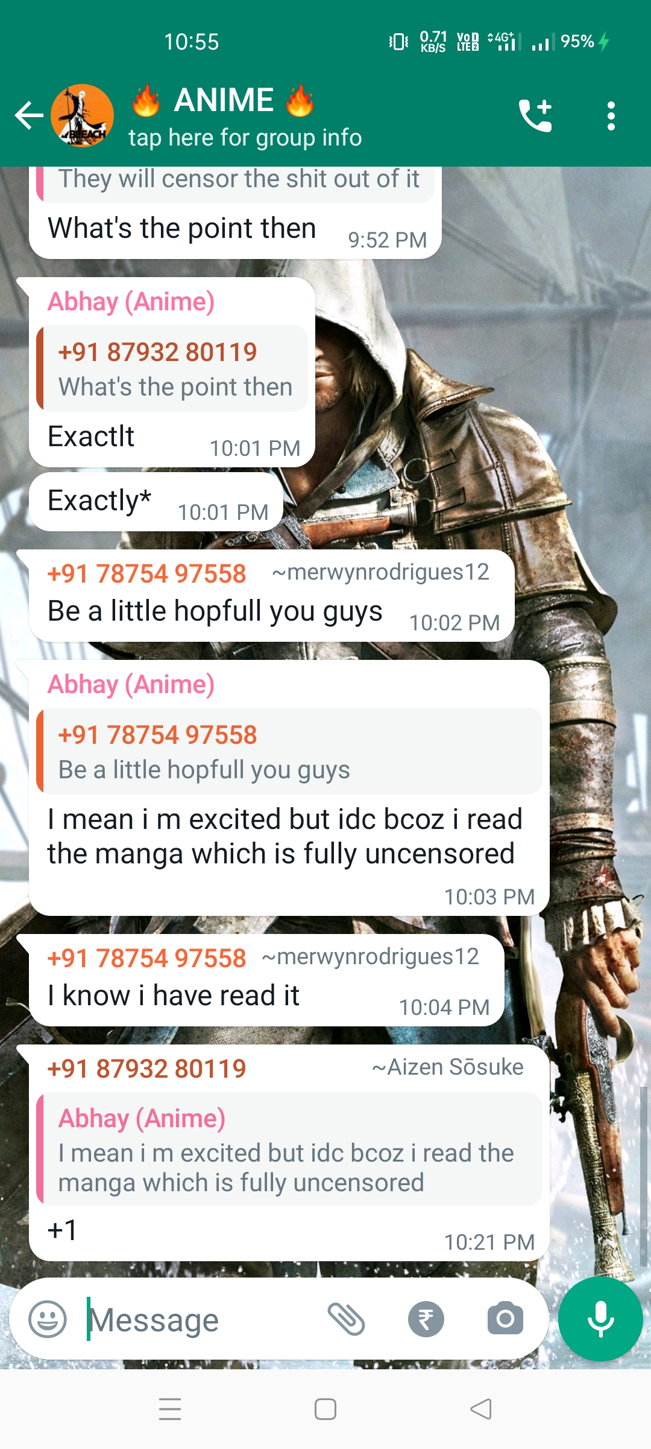

1. THREE DOT UPON CLICKING SMALL SCREEN

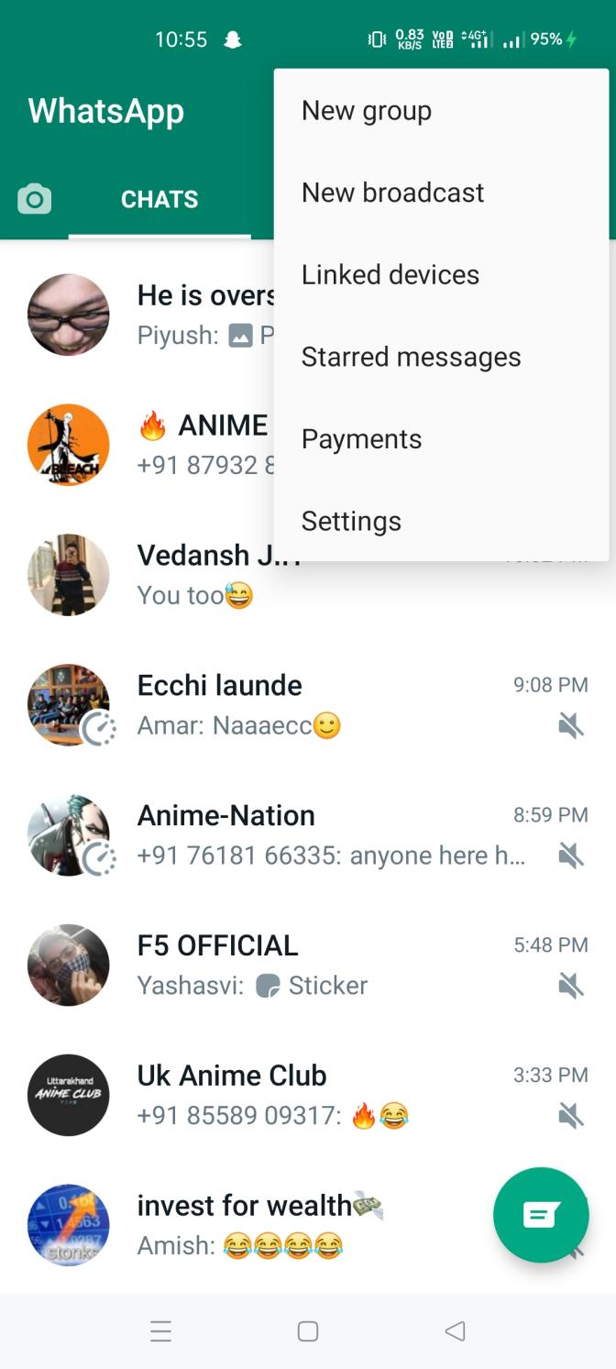

1. SEARCH BUTTON RESPONSE

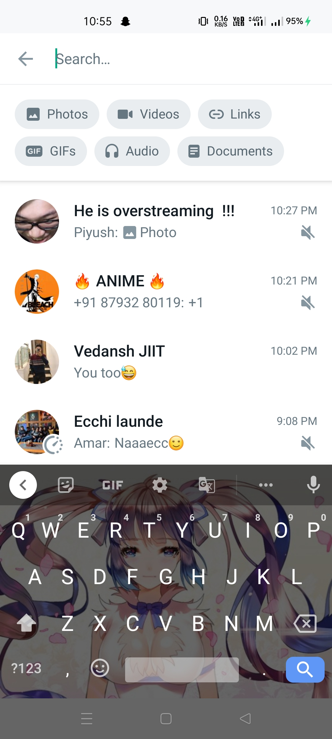

1. NEW CHAT BUTTON RESPONSE

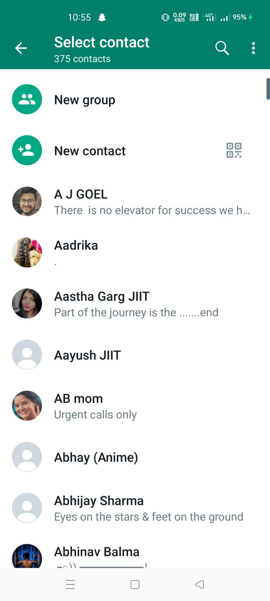

1. SETTING PAGE

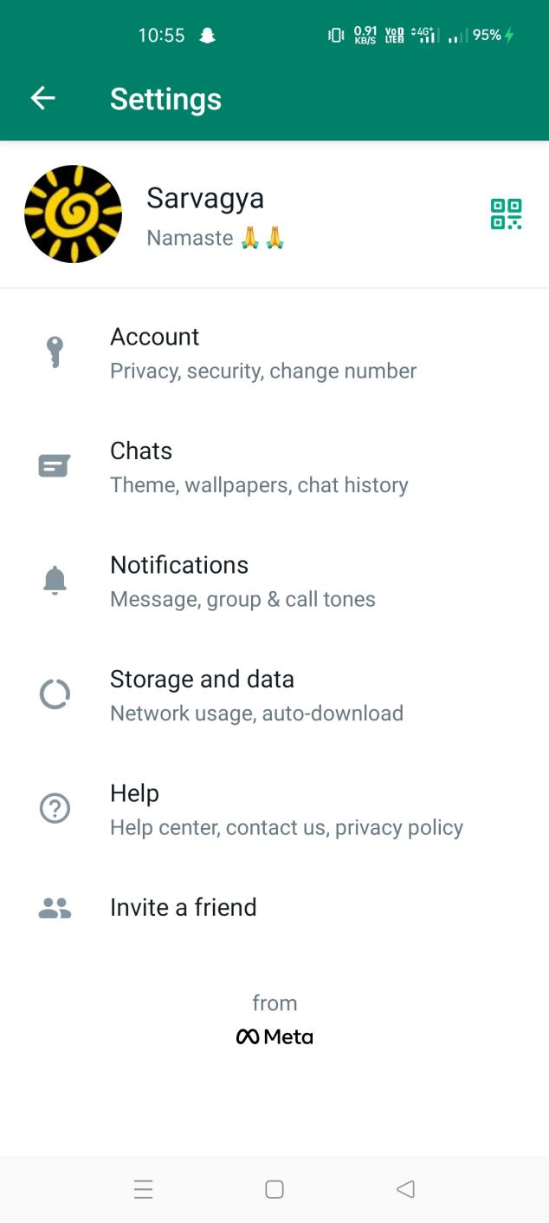

1. STARRED MESSAGE RESPONSE

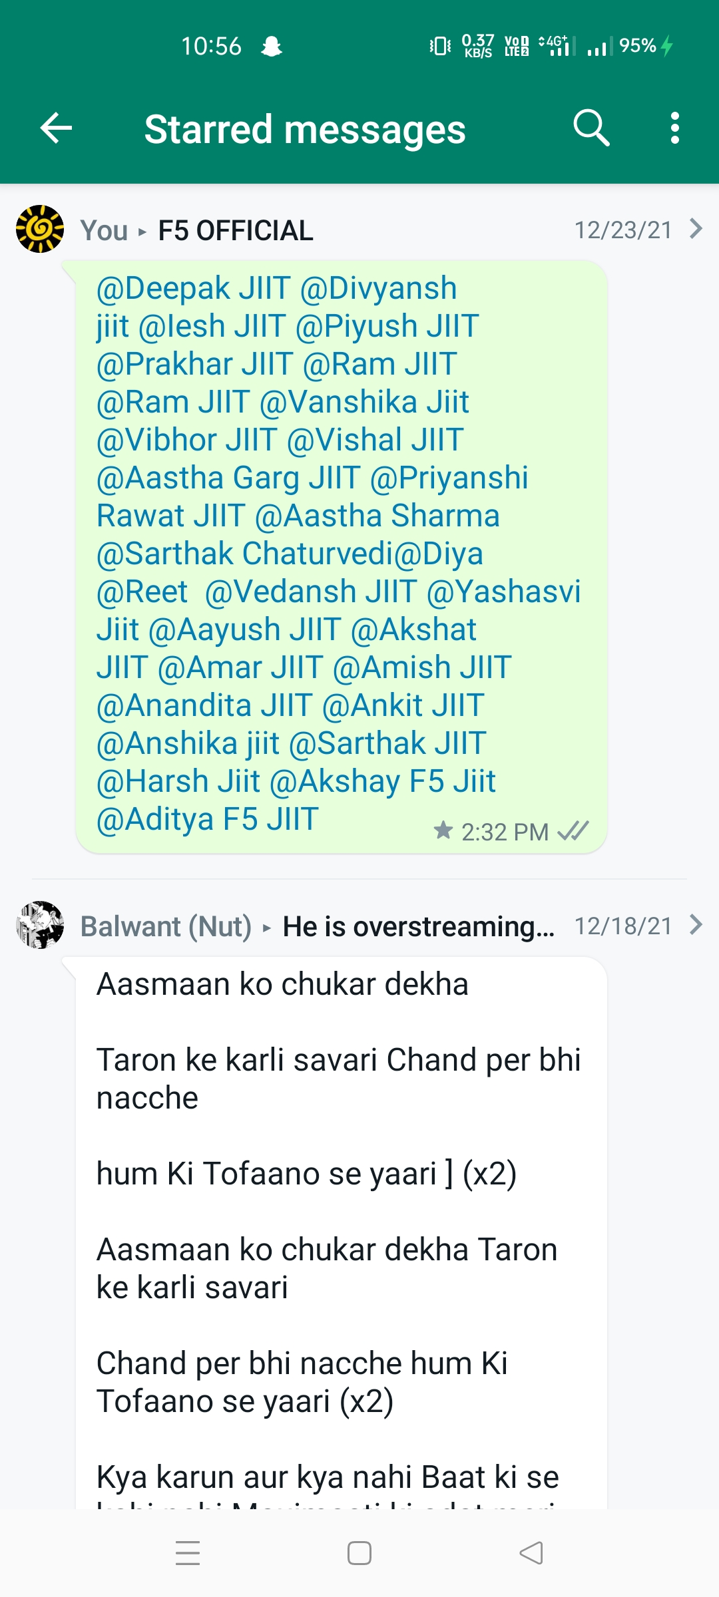

1. LINKED DEVICE BUTTON RESPONSE

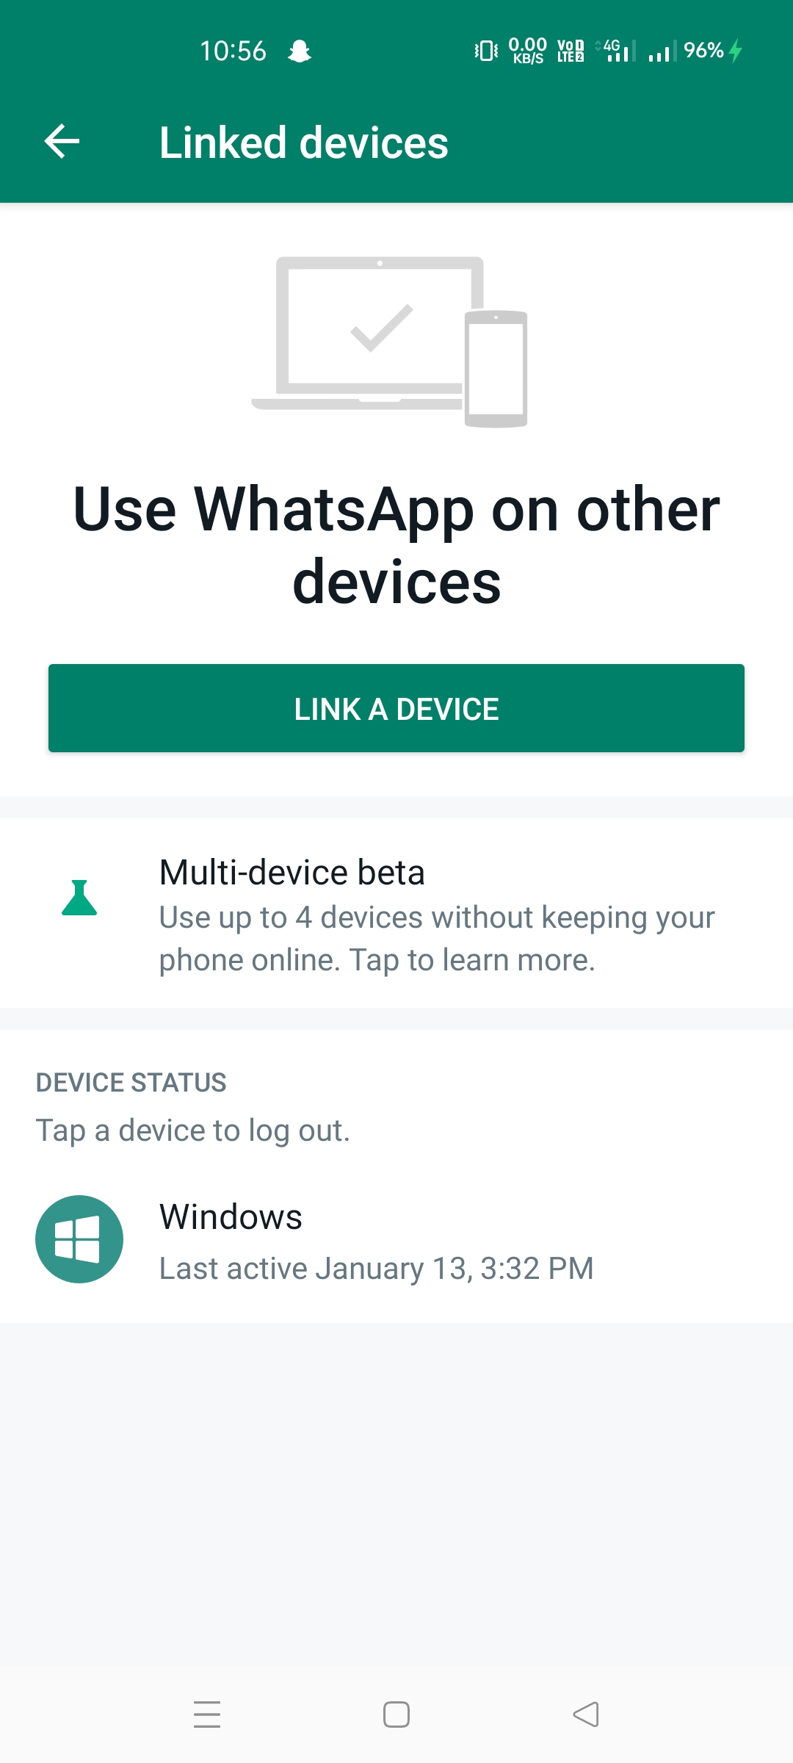

1. BROADCAST BUTTON RESPONSE

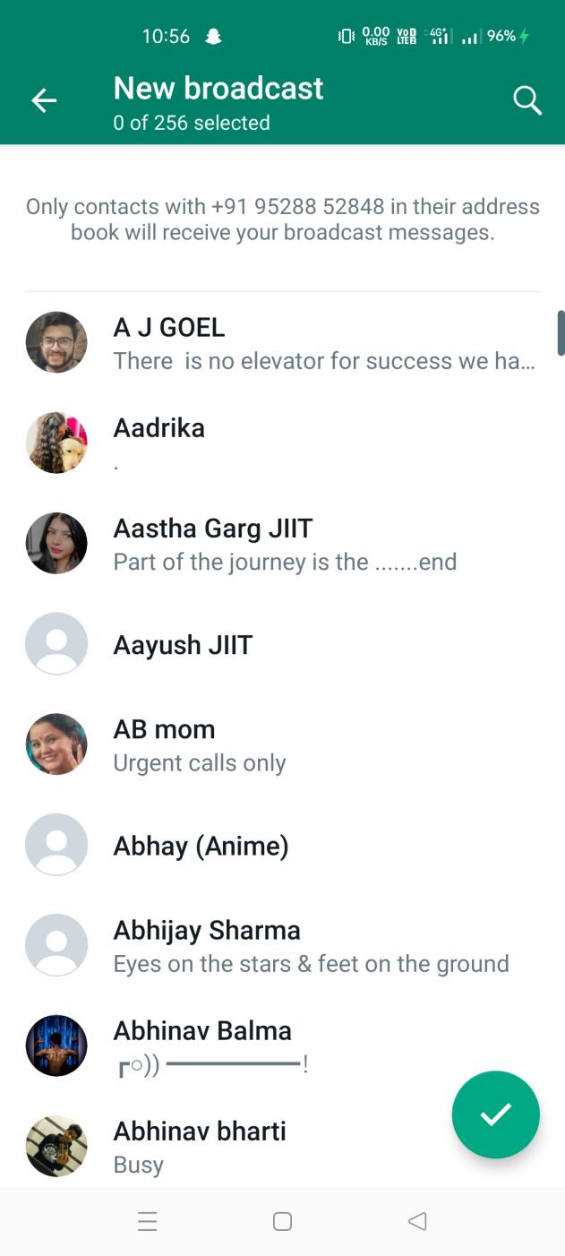

1. NEW GROUP BUTTON RESPONSE

